**Supplemental Materials**

**Section 1: Questionnaire**

**Summary of Questions**

At this stage, we are preparing to present the results of our brainstorming sessions. We have created a survey and hope to finalize it with your valuable input. Please take the time to answer these questions and share your opinions. Your feedback will greatly help us improve our survey. We are thankful for your attention and grateful for your assistance in this important matter.

### Key Guidelines for Responses:

1. **Address Each Question Thoughtfully:**
   * Provide detailed answers based on your experience and understanding.
   * Reflect on the challenges and opportunities of using AI at each step of the diagnostic process.
2. **Focus on Both Challenges and Opportunities:**
   * Mention any specific challenges you foresee or have encountered, such as technical difficulties, user resistance, or ethical concerns.
   * Highlight potential opportunities AI could bring, such as improving accuracy, streamlining workflows, or enhancing patient care.
3. **Step-by-Step Analysis of the Clinical Workflow:**
   * For each stage of the clinical diagnostic workflow (from test ordering to report communication), think about how AI could be integrated in real practice.
   * Identify challenges and opportunities relevant to that particular stage.

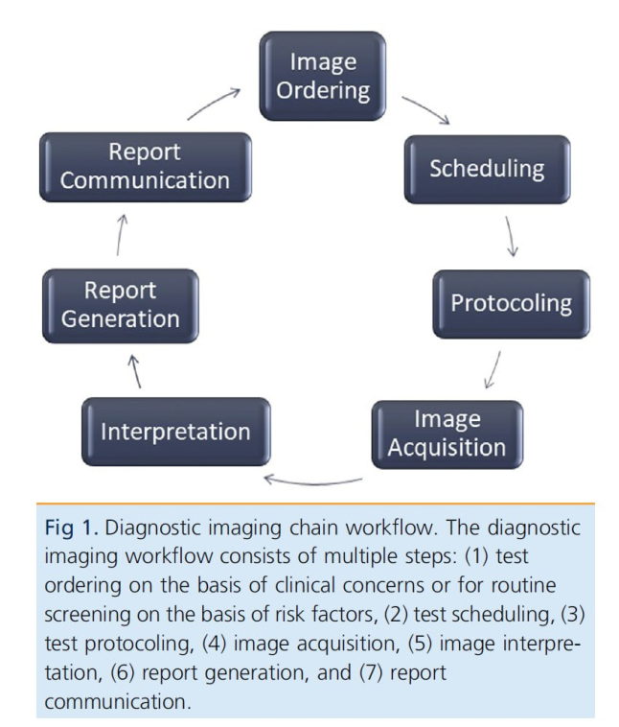

1. **Answer in English:**
   * Please ensure your answers are written in **English** for consistency and clarity.
   * You can use AI chatbots or tools to help with grammar and editing, but **make sure the core content and meaning of your response remain unchanged.**
   * While using AI tools for assistance, **ensure that your original ideas and concerns are preserved.**
   * **Please do not let automated tools alter the essence of your responses** or diminish the accuracy of the information.
2. **Let’s keep the Bigger Picture in Mind:**
   * When thinking about AI's integration into clinical diagnostics workflow, consider both short-term and long-term implications, as well as how these changes could benefit or challenge healthcare systems.
   * **Stay Specific:** While discussing general trends or issues is fine, specific examples (personal or observed) will add depth and relevance to your answers.

Thank you so much for your time and consideration!

# Demographic questions: Please fill in your info

* 1. Full Name (optional)
  2. Gender
* Male
* Female
* Non-Binary
* Others
* Prefer not to say
  1. City and Country
  2. Age
  3. Academic degree (You can select more than one option. Check all that apply.)
* MD or equivalents
* PhD or equivalents
* MSc or equivalent
* MPH or equivalents
* Other, please specify ….
  1. Position (Mark one or more).
* Physician
* Trainee:

Intern

Medical Residents

Fellow

* Academic Researcher
* Other, please specify ….
  1. Primary medical discipline (e.g. Radiology, Cardiology, …)
  2. Primary affiliation
* University / Teaching Hospital or Institution
* Independent Hospital
* Independent Research Institute
* Independent Clinical Institute/Center
* Government Health Program (such as Government ministry or department)
* Private Practice
* Others, please specify ….
  1. Years of experience in AI in medicine
  2. Affiliation 1

* 1. Affiliation 2
  2. Email address

Please write the e-mail address that you check frequently.

# Category 1: Test Ordering

1. Do you agree that AI can assist in selecting the most appropriate diagnostic test based on clinical concerns or risk factors??
   * Strongly agree
   * Agree
   * Neutral
   * Disagree
   * Strongly disagree

***Scenario Example #1****:* In a general hospital, an AI system has been implemented to help doctors choose the most suitable diagnostic tests. For example, a patient comes in with symptoms of a possible heart condition. The doctor inputs the patient's symptoms and history into the AI system, which recommends an echocardiogram instead of an ECG due to specific risk factors the AI identified. The doctor was initially considering an ECG but agrees with the AI’s suggestion, leading to a more accurate diagnosis.

* Could you please elaborate on the challenges you are facing in using AI at this stage of diagnostic clinical practices, based on the scenario and question mentioned above?
* Could you please share more details about the opportunities you see in using AI at this stage of diagnostic clinical practices, based on the scenario and question mentioned above?

------------------------------------------------------------------------------------------

1. Do you agree that AI tools are effective in reducing duplicate examination orders?
   * Strongly agree
   * Agree
   * Neutral
   * Disagree
   * Strongly disagree

***Scenario Example #1****:* At a busy urban clinic, an AI system is used to track and manage patient tests. When a patient who had a blood test at another facility comes in, the AI system identifies the previous test and alerts the doctor, preventing unnecessary duplicate testing. This system has significantly reduced redundant tests, saving time and resources.

* Could you please elaborate on the challenges you are facing in using AI at this stage of diagnostic clinical practices, based on the scenario and question mentioned above?
* Could you please share more details about the opportunities you see in using AI at this stage of diagnostic clinical practices, based on the scenario and question mentioned above?

-------------------------------------------------------------------------------------------

1. Do you agree that AI can enhance the accuracy of allergy history in test ordering?
   * Strongly agree
   * Agree
   * Neutral
   * Disagree
   * Strongly disagree

***Scenario Example #1:***  In a pediatric clinic, an AI tool assists in managing patient histories. When ordering a new test, the AI cross-references the child’s allergy history, which is often updated and sometimes incomplete. The AI system flags a potential allergy risk that the doctor missed, ensuring the child receives a safe alternative medication.

* Could you please elaborate on the challenges you are facing in using AI at this stage of diagnostic clinical practices, based on the scenario and question mentioned above?
* Could you please share more details about the opportunities you see in using AI at this stage of diagnostic clinical practices, based on the scenario and question mentioned above?

-------------------------------------------------------------------------------------------

1. Do you agree that AI can integrate with clinical decision support systems to improve test ordering?
   * Strongly agree
   * Agree
   * Neutral
   * Disagree
   * Strongly disagree

***Scenario Example #1:*** A cardiology department uses an AI-enhanced clinical decision support system (CDSS) to improve test ordering. A doctor enters patient data, and the AI integrates this with existing clinical guidelines and patient history. The AI suggests a stress test instead of a resting ECG, based on the patient’s recent symptoms and history, improving the accuracy and efficiency of the diagnosis.

* Could you please elaborate on the challenges you are facing in using AI at this stage of diagnostic clinical practices, based on the scenario and question mentioned above?
* Could you please share more details about the opportunities you see in using AI at this stage of diagnostic clinical practices, based on the scenario and question mentioned above?

-------------------------------------------------------------------------------------------

# Category 2: Test Scheduling

1. Do you agree that AI can optimize staffing by predicting patient appointment durations accurately?
   * Strongly agree
   * Agree
   * Neutral
   * Disagree
   * Strongly disagree

***Scenario Example #1:***  In a cardiology clinic, AI is used to predict the duration of patient appointments based on historical data and individual patient profiles. This helps the clinic allocate staff more effectively, ensuring that each appointment is given the appropriate amount of time without overbooking or underbooking. As a result, the clinic has seen improved staff efficiency and patient satisfaction.

* Could you please elaborate on the challenges you are facing in using AI at this stage of diagnostic clinical practices, based on the scenario and question mentioned above?
* Could you please share more details about the opportunities you see in using AI at this stage of diagnostic clinical practices, based on the scenario and question mentioned above?

-------------------------------------------------------------------------------------------

1. Do you agree that AI can optimize workflow for test scheduling in a radiology department?
   * Strongly agree
   * Agree
   * Neutral
   * Disagree
   * Strongly disagree

***Scenario Example #1:***  In a large hospital, AI is used to manage the workflow for MRI scan scheduling. The AI system considers factors such as patient urgency, machine availability, and previous appointment delays to allocate slots more efficiently. This optimization has led to a smoother scheduling process, reducing patient wait times and enhancing the overall efficiency of the radiology department.

* Could you please elaborate on the challenges you are facing in using AI at this stage of diagnostic clinical practices, based on the scenario and question mentioned above?
* Could you please share more details about the opportunities you see in using AI at this stage of diagnostic clinical practices, based on the scenario and question mentioned above?

-------------------------------------------------------------------------------------------

1. Do you agree that AI has potential benefits in predicting patient "no-shows"?
   * Strongly agree
   * Agree
   * Neutral
   * Disagree
   * Strongly disagree

***Scenario Example #1:*** A dermatology clinic employs an AI system to predict patient no-shows based on historical data and current trends. By identifying patients likely to miss appointments, the clinic can send reminders or double-book slots, significantly reducing the number of missed appointments and optimizing the schedule.

* Could you please elaborate on the challenges you are facing in using AI at this stage of diagnostic clinical practices, based on the scenario and question mentioned above?
* Could you please share more details about the opportunities you see in using AI at this stage of diagnostic clinical practices, based on the scenario and question mentioned above?

-------------------------------------------------------------------------------------------

1. Do you agree that AI can optimize the workflow by predicting patient wait times for imaging appointments?
   * Strongly agree
   * Agree
   * Neutral
   * Disagree
   * Strongly disagree

***Scenario Example #1:*** In a large oncology center, AI analyzes patient flow data and historical appointment durations to predict wait times for PET scans. Patients receive updates through a mobile app, allowing them to plan their arrival accordingly, thus enhancing their overall experience and reducing overcrowding in the waiting area.

* Could you please elaborate on the challenges you are facing in using AI at this stage of diagnostic clinical practices, based on the scenario and question mentioned above?
* Could you please share more details about the opportunities you see in using AI at this stage of diagnostic clinical practices, based on the scenario and question mentioned above?

-------------------------------------------------------------------------------------------

1. Do you agree that AI can improve the workflow by predicting and managing appointment delays for imaging tests?
   * Strongly agree
   * Agree
   * Neutral
   * Disagree
   * Strongly disagree

***Scenario Example #1:*** In a busy radiology department, AI monitors equipment status, staff availability, and incoming emergency cases to predict potential delays in scheduled CT scans. The system alerts both staff and patients about delays, allowing for timely rescheduling and better management of the imaging workflow.

* Could you please elaborate on the challenges you are facing in using AI at this stage of diagnostic clinical practices, based on the scenario and question mentioned above?
* Could you please share more details about the opportunities you see in using AI at this stage of diagnostic clinical practices, based on the scenario and question mentioned above?

-------------------------------------------------------------------------------------------

1. Do you agree that AI can help in improving follow-up rates for patients with specific diagnostic needs?
   * Strongly agree
   * Agree
   * Neutral
   * Disagree
   * Strongly disagree

***Scenario Example #1:*** In a diabetes clinic, AI helps in tracking and managing follow-up appointments for patients with high-risk conditions. The AI identifies patients who are due for follow-up visits based on their medical records and automatically schedules appointments, sends reminders, and follows up with those who miss their appointments, leading to improved patient outcomes.

* Could you please elaborate on the challenges you are facing in using AI at this stage of diagnostic clinical practices, based on the scenario and question mentioned above?
* Could you please share more details about the opportunities you see in using AI at this stage of diagnostic clinical practices, based on the scenario and question mentioned above?

# Category 3: Test Protocoling

1. Do you agree that AI may automate the vetting of imaging protocols with clinical indications?
   * Strongly agree
   * Agree
   * Neutral
   * Disagree
   * Strongly disagree

***Scenario Example #1:*** In a radiology department, an AI system is implemented to automate the protocoling process for imaging exams. When a neuroradiology MRI is ordered, the AI reviews the patient's clinical indications and demographic data, automatically selecting the most appropriate MRI protocol. This system helps ensure that each imaging exam is precisely tailored to the patient's needs, improving accuracy and efficiency while reducing the need for radiologist intervention in routine cases.

* Could you please elaborate on the challenges you are facing in using AI at this stage of diagnostic clinical practices, based on the scenario and question mentioned above?
* Could you please share more details about the opportunities you see in using AI at this stage of diagnostic clinical practices, based on the scenario and question mentioned above?

1. Do you agree that AI can play a significant role in protocoling high-frequency, low-variability orders?
   * Strongly agree
   * Agree
   * Neutral
   * Disagree
   * Strongly disagree

***Scenario Example #1:*** A busy emergency department uses AI to manage protocoling for common imaging orders, like X-rays for suspected fractures. The AI quickly processes these high-frequency, low-variability requests based on predefined protocols, allowing radiologists to focus on more complex cases, improving overall efficiency.

* Could you please elaborate on the challenges you are facing in using AI at this stage of diagnostic clinical practices, based on the scenario and question mentioned above?
* Could you please share more details about the opportunities you see in using AI at this stage of diagnostic clinical practices, based on the scenario and question mentioned above?

-------------------------------------------------------------------------------------------

1. Do you agree that AI can handle add-on or emergent protocols effectively?
   * Strongly agree
   * Agree
   * Neutral
   * Disagree
   * Strongly disagree

***Scenario Example #1:*** During a busy shift in the ICU, an AI system assists with managing add-on and emergent imaging protocols. When a critically ill patient requires an urgent MRI, the AI prioritizes and protocols the request immediately, ensuring the patient receives timely and appropriate imaging without delays.

* Could you please elaborate on the challenges you are facing in using AI at this stage of diagnostic clinical practices, based on the scenario and question mentioned above?
* Could you please share more details about the opportunities you see in using AI at this stage of diagnostic clinical practices, based on the scenario and question mentioned above?

# Category 4: Image Acquisition

1. Do you agree that AI can enhance imaging quality with respect to acquisition times, etc.?
   * Strongly agree
   * Agree
   * Neutral
   * Disagree
   * Strongly disagree

***Scenario Example #1:*** In a pediatric radiology department, an AI tool optimizes MRI sequences to shorten scan times while maintaining image quality. This results in faster imaging sessions, which is particularly beneficial for young patients who may struggle to remain still during long procedures.

* Could you please elaborate on the challenges you are facing in using AI at this stage of diagnostic clinical practices, based on the scenario and question mentioned above?
* Could you please share more details about the opportunities you see in using AI at this stage of diagnostic clinical practices, based on the scenario and question mentioned above?

1. Do you agree that AI can reduce the dose of contrast used in imaging studies?
   * Strongly agree
   * Agree
   * Neutral
   * Disagree
   * Strongly disagree

***Scenario Example #1:*** A radiology clinic uses AI to adjust the contrast dose for CT scans based on patient-specific factors. The AI calculates the minimal effective dose required to achieve high-quality images, reducing the risk of side effects and enhancing patient safety.

* Could you please elaborate on the challenges you are facing in using AI at this stage of diagnostic clinical practices, based on the scenario and question mentioned above?
* Could you please share more details about the opportunities you see in using AI at this stage of diagnostic clinical practices, based on the scenario and question mentioned above?

-------------------------------------------------------------------------------------------

1. Do you agree that AI can improve the quality of low-dose contrast-enhanced MR images (like image-to-image translation methods, etc.)?
   * Strongly agree
   * Agree
   * Neutral
   * Disagree
   * Strongly disagree

***Scenario Example #1:*** In an advanced imaging center, AI algorithms enhance the low quality of low-dose contrast-enhanced MR images. This technology allows clinicians to obtain higher quality images with less contrast agent, reducing potential adverse reactions in patients.

* Could you please elaborate on the challenges you are facing in using AI at this stage of diagnostic clinical practices, based on the scenario and question mentioned above?
* Could you please share more details about the opportunities you see in using AI at this stage of diagnostic clinical practices, based on the scenario and question mentioned above?

-------------------------------------------------------------------------------------------

1. Do you agree that AI has benefits in reconstructing undersampled image data?
   * Strongly agree
   * Agree
   * Neutral
   * Disagree
   * Strongly disagree

***Scenario Example #1:*** A research hospital utilizes AI to reconstruct undersampled PET data, producing high-quality images from shorter scan times. This innovation benefits patients who cannot tolerate long PET sessions and helps in achieving faster diagnostics.

* Could you please elaborate on the challenges you are facing in using AI at this stage of diagnostic clinical practices, based on the scenario and question mentioned above?
* Could you please share more details about the opportunities you see in using AI at this stage of diagnostic clinical practices, based on the scenario and question mentioned above?

# Category 5: Image Interpretation

1. Do you agree that AI can improve the consistency and accuracy of image interpretation?
   * Strongly agree
   * Agree
   * Neutral
   * Disagree
   * Strongly disagree

***Scenario Example #1:*** In a large-scale diagnostic imaging center, AI assists radiologists by pre-analyzing scans for conditions like fractures and tumors, highlighting areas of concern. This speeds up interpretation and increases accuracy. At the center's cancer treatment facility, AI detects abnormalities in mammograms, identifying early-stage cancer that might be missed by the human eye. AI tools also standardize image interpretation across the practice, reducing variability between radiologists and ensuring more consistent and accurate diagnoses, thus enhancing patient care.

* Could you please elaborate on the challenges you are facing in using AI at this stage of diagnostic clinical practices, based on the scenario and question mentioned above?
* Could you please share more details about the opportunities you see in using AI at this stage of diagnostic clinical practices, based on the scenario and question mentioned above?

-------------------------------------------------------------------------------------------

# Category 6: Report Generation

1. Do you agree that AI can assist in the reporting and documentation of diagnostic findings by automating the generation of diagnostic reports?
   * Strongly agree
   * Agree
   * Neutral
   * Disagree
   * Strongly disagree

***Scenario Example #1:*** In a state-of-the-art hospital and a large diagnostic center, AI systems are integrated into the radiology departments to assist in reporting and documenting diagnostic findings. When a radiologist completes an imaging study, the AI analyzes the images and generates a preliminary report highlighting key findings and compiling relevant clinical information into a structured format. The radiologist reviews and finalizes this report, ensuring all critical information is accurately documented. This AI assistance reduces the workload of radiologists, allowing them to focus on complex cases, significantly speeds up report generation, and improves overall efficiency and accuracy.

* Could you please elaborate on the challenges you are facing in using AI at this stage of diagnostic clinical practices, based on the scenario and question mentioned above?
* Could you please share more details about the opportunities you see in using AI at this stage of diagnostic clinical practices, based on the scenario and question mentioned above?

1. Do you agree that AI can ensure the completeness and accuracy of diagnostic reports?
   * Strongly agree
   * Agree
   * Neutral
   * Disagree
   * Strongly disagree

***Scenario Example #1:*** At a renowned medical research institution, AI is utilized to enhance the completeness and accuracy of diagnostic reports. The AI system cross-references patient data, imaging results, and clinical guidelines to ensure all relevant information is included in the report. It also identifies and flags any inconsistencies or missing data for the radiologist to review. This comprehensive approach ensures that diagnostic reports are thorough and accurate, reducing the risk of errors and improving patient outcomes.

* Could you please elaborate on the challenges you are facing in using AI at this stage of diagnostic clinical practices, based on the scenario and question mentioned above?
* Could you please share more details about the opportunities you see in using AI at this stage of diagnostic clinical practices, based on the scenario and question mentioned above?

1. Do you agree that AI can integrate with electronic health records to streamline report generation?
   * Strongly agree
   * Agree
   * Neutral
   * Disagree
   * Strongly disagree

***Scenario Example #1:***  In a technologically advanced hospital, AI systems are integrated with electronic health records (EHRs) to streamline report generation. When a diagnostic study is completed, the AI automatically retrieves relevant patient data from the EHR and incorporates it into the diagnostic report. This integration eliminates the need for manual data entry, reducing errors and saving time. The seamless flow of information between the AI and EHR systems ensures that reports are generated quickly and accurately, enhancing overall efficiency.

* Could you please elaborate on the challenges you are facing in using AI at this stage of diagnostic clinical practices, based on the scenario and question mentioned above?
* Could you please share more details about the opportunities you see in using AI at this stage of diagnostic clinical practices, based on the scenario and question mentioned above?

# Category 7: Report Communication

1. Do you agree that AI can improve the communication of diagnostic reports to referring physicians?
   * Strongly agree
   * Agree
   * Neutral
   * Disagree
   * Strongly disagree

***Scenario Example #1:*** In a busy multi-specialty clinic, AI technology is used to enhance the communication of diagnostic reports to referring physicians. Once a report is finalized, the AI system automatically sends it to the appropriate referring physician through a secure electronic platform. Additionally, the AI can generate summaries and highlight critical findings, ensuring that physicians receive clear and concise information. This improved communication streamlines the workflow and ensures timely updates for better patient management.

* Could you please elaborate on the challenges you are facing in using AI at this stage of diagnostic clinical practices, based on the scenario and question mentioned above?
* Could you please share more details about the opportunities you see in using AI at this stage of diagnostic clinical practices, based on the scenario and question mentioned above?

1. Do you agree that AI can facilitate patient access to their diagnostic reports?
   * Strongly agree
   * Agree
   * Neutral
   * Disagree
   * Strongly disagree

***Scenario Example #1:*** At a patient-centered medical facility, AI systems are designed to facilitate patient access to their diagnostic reports. After a report is finalized, the AI automatically uploads it to a secure patient portal. Patients receive notifications and can access their reports online, along with explanations and visual aids to help them interpret the findings for different audiences, such as family members or other healthcare providers. This AI assistance provides detailed, patient-friendly summaries and interactive tools to clarify medical terminology, empowering patients to be more involved in their healthcare and fostering better communication between patients and healthcare providers. This transparency enhances patient understanding and engagement, ensuring they can make informed decisions about their health.

* Could you please elaborate on the challenges you are facing in using AI at this stage of diagnostic clinical practices, based on the scenario and question mentioned above?
* Could you please share more details about the opportunities you see in using AI at this stage of diagnostic clinical practices, based on the scenario and question mentioned above?

1. Do you agree that AI can enhance the timeliness and reliability of report delivery?
   * Strongly agree
   * Agree
   * Neutral
   * Disagree
   * Strongly disagree

***Scenario Example #1:*** In an emergency care hospital, AI is implemented to enhance the timeliness and reliability of report delivery. The AI system prioritizes urgent cases, ensuring that critical diagnostic reports are generated and delivered to healthcare providers without delay. It also monitors the delivery process, verifying that reports reach the intended recipients. This enhanced reliability ensures that healthcare providers have timely access to crucial diagnostic information, leading to faster and more effective patient care.

* Could you please elaborate on the challenges you are facing in using AI at this stage of diagnostic clinical practices, based on the scenario and question mentioned above?
* Could you please share more details about the opportunities you see in using AI at this stage of diagnostic clinical practices, based on the scenario and question mentioned above?

# Category 8: General Applications

1. Do you agree that AI can be utilized across different medical specialties to improve diagnostic workflows?
   * Strongly agree
   * Agree
   * Neutral
   * Disagree
   * Strongly disagree

***Scenario Example #1:*** In a multidisciplinary hospital, AI systems are employed across various medical specialties, including radiology, cardiology, and oncology. These AI tools assist in diagnosing conditions, optimizing test orders, and streamlining workflows. For instance, in cardiology, AI analyzes ECGs for arrhythmias, while in oncology, it detects early signs of cancer in imaging studies. This cross-specialty utilization of AI enhances diagnostic accuracy and efficiency, leading to better patient care.

* Could you please elaborate on the challenges you are facing in using AI at this stage of diagnostic clinical practices, based on the scenario and question mentioned above?
* Could you please share more details about the opportunities you see in using AI at this stage of diagnostic clinical practices, based on the scenario and question mentioned above?

1. Do you agree that there are potential challenges and barriers to implementing AI in diagnostic workflows?
   * Strongly agree
   * Agree
   * Neutral
   * Disagree
   * Strongly disagree

***Scenario Example #1:*** At a regional healthcare system, administrators face several challenges in implementing AI in diagnostic workflows. These include high initial costs, the need for staff training, integration issues with existing systems, and concerns about data privacy and security. Additionally, some healthcare providers are skeptical about relying on AI for critical diagnostic decisions, preferring traditional methods. Overcoming these barriers requires significant investment, education, and robust security measures.

* Could you please elaborate on the challenges you are facing in using AI at this stage of diagnostic clinical practices, based on the scenario and question mentioned above?
* Could you please share more details about the opportunities you see in using AI at this stage of diagnostic clinical practices, based on the scenario and question mentioned above?

**Section 2: Analyses**

**Supplemental Table S1. Generated Statements and Resources**

|  |  |  |  |  |
| --- | --- | --- | --- | --- |
| **Numbers** | **Statement** | **Diagnosis Workflow Steps** | **Source** | **Reference** |
| **1** | AI may inadvertently increase image acquisition times if protocols are not streamlined for specific imaging modalities. | Image Acquisition | Interviews |  |
| **2** | Technical staff may resist AI-driven acquisition protocols, fearing loss of autonomy in decision-making during imaging procedures. | Image Acquisition | Interviews |  |
| **3** | AI systems might fail to account for patient comfort during image acquisition, such as tailoring protocols to minimize waiting or scanning times. | Image Acquisition | Interviews |  |
| **4** | Limited integration of AI tools with imaging hardware creates inefficiencies in the acquisition process​​. | Image Acquisition | Interviews |  |
| **5** | Insufficient training for technicians on using AI for image acquisition reduces its impact on workflow optimization​​. | Image Acquisition | Interviews |  |
| **6** | Concerns about AI-assisted acquisition tools introducing bias in image quality impede adoption​​. | Image Acquisition | Interviews |  |
| **7** | AI tools may not optimize image acquisition for complex or atypical cases, leading to diagnostic gaps. | Image Acquisition | Interviews |  |
| **8** | Many facilities lack compatible hardware to integrate AI into image acquisition workflows. | Image Acquisition | Hospitals with smaller IT infrastructure are also implementing both types of tools. They are struggling with the same issues of clinician buy-in, alert optimization, distrust, and confusion with even wider gaps between clinician and IT leaders without always having informaticians to serve as a bridge | Implementation approaches and barriers for rule-based and machine learning-based sepsis risk prediction tools a qualitative study.pdf |
| **9** | Lack of technician training on AI-assisted image acquisition reduces its utility. | Image Acquisition | As AI becomes more ingrained into day-to-day clinical practice, it is important that frontline patient care staff understand the technology, its capabilities and its limitations | A lesson in implementation a pre-post study of providers’ experience with artificial intelligence-based clinical decision support.pdf |
| **10** | AI tools may require modifications to image acquisition workflows that do not align with current practices. | Image Acquisition | The addition of system and artificial intelligence to image acquisition is seen as a solution that will enable a more patient-focused workflow by addressing the increased patient throughput and the need for greater efficiency | Impact of intelligent virtual and AI-based automated collimation   functionalities on the efficiency of radiographic acquisitions  Rezazade Mehrizi MH, van Ooijen P, Homan M. Applications of artificial intelligence (AI) in diagnostic radiology: a technography study. Eur Radiol 2021   Apr;31(4):1805e11. https://doi.org/10.1007/s00330-020-07230-9. Epub 2020   Sep 18. PMID: 32945967; PMCID: PMC7979626. |
| **11** | Limited integration of AI tools with imaging hardware reduces their utility during image acquisition​​. | Image Acquisition | The AI software could not be implemented without essential medical supplies to generate clinical source data | Barriers and facilitators to implementing imaging-based diagnostic artificial intelligence-assisted decision-making software in hospitals in China a qualitative study using the updated Consolidated Framework for Implemen.pdf |
| **12** | Inadequate training for technicians on AI-assisted image acquisition limits effectiveness​​. | Image Acquisition | clinicians, in general, wish to understand the scientific and clinical basis upon which recommendations are based so that they can independently judge their validity and ensure they apply to the patient | A lesson in implementation a pre-post study of providers’ experience with artificial intelligence-based clinical decision support.pdf  Shortliffe EH, Sepulveda MJ. Clinical Decision Support in the Era of Artificial Intelligence.   JAMA. 2018 Dec 4;320(21):2199-200. PMID: 30398550. doi: 10.1001/jama.2018.17163.f |
| **13** | AI tools for image acquisition may perpetuate biases in image quality, particularly for underrepresented populations​ | Image Acquisition | Using ML, it is very difficult to ensure that the outputs don’t reflect input biases during the creation or coding of the dataset | Barriers and Opportunities Regarding Implementation of a Machine Learning-Based Acute Heart Failure Risk Stratification Tool in the Emergency Department.pdf |
| **14** | AI recommendations for image ordering may be limited by data integration issues between healthcare facilities, leading to incomplete patient histories and suboptimal orders. | Image Ordering | Interviews |  |
| **15** | Clinicians may distrust AI-generated imaging orders if they believe the system lacks the nuanced reasoning needed for patient-specific conditions. | Image Ordering | Interviews |  |
| **16** | Medical-legal liability concerns could discourage clinicians from relying on AI tools for image ordering when deviations from traditional guidelines occur. | Image Ordering | Interviews |  |
| **17** | AI systems may fail to adapt to local resource constraints, such as the availability of certain imaging modalities, complicating the ordering process. | Image Ordering | Interviews |  |
| **18** | AI decisions on image ordering are not acceptable for insurance companies | Image Ordering | Interviews |  |
| **19** | Lack of integration between AI systems and existing clinical tools complicates the prioritization and accuracy of imaging orders​​. | Image Ordering | Interviews |  |
| **20** | Inadequate standardization in AI algorithms for triaging imaging requests creates inefficiencies in image ordering​​. | Image Ordering | Interviews |  |
| **21** | Limited training for clinicians on AI-assisted decision support for image ordering reduces its effectiveness​​. | Image Ordering | Interviews |  |
| **22** | AI models trained on limited datasets may not generalize well, resulting in inappropriate or missed image orders, which can lead to diagnostic errors. | Image Ordering | FS reference image. However, this is not possible in prospective studies leading to the need  for methods for automatically choosing the regularization parameters.  Recently, DL methods showed promising initial results for image reconstruction, fully  automated cartilage segmentation, and quantitative compositional mapping. One challenge  when using DL approaches is the difficulty in obtaining large training datasets to optimize  model performance. Simulated datasets have been recently used to generate large training | Updates on Compositional MRI Mapping of the Cartilage.pdf |
| **23** | Poor integration of AI into image ordering workflows can disrupt clinician efficiency and decision-making processes. | Image Ordering | ability to favorably impact patient outcomes; in contrast, barriers included interference with   established workflow, recommendations that are perceived as unhelpful or irrelevant, and time   pressures [8]. Workflow interference may include delivery of irrelevant or confusing   recommendations which may come at an inconvenient time when the user is not prepared to   consider or act on them [5]. This has resulted in the all-too-common phenomenon of “alert-   fatigue”. In order to address these problems, frameworks such as the “Five Rights of CDS” and | A lesson in implementation a pre-post study of providers’ experience with artificial intelligence-based clinical decision support.pdf  Shortliffe EH, Sepulveda MJ. Clinical Decision Support in the Era of Artificial Intelligence.   JAMA. 2018 Dec 4;320(21):2199-200. PMID: 30398550. doi: 10.1001/jama.2018.17163. |
| **24** | Training data biases in AI algorithms can lead to inequitable prioritization or inappropriate image orders for certain populations. | Image Ordering | Problematic judgments reflecting biases in training data have previously been demonstrated in AI systems applied in nonmedical domains. For example, software meant to assist judges in determining a defendant’s sentence by estimating the likelihood of recidivism has a disturbing evidence of bias. In the absence of genetic research in particular groups, an algorithm developed to forecast outcomes based on genetic data may similarly exhibit bias | Navigating the ethical landscape of artificial intelligence in radiography a cross-sectional study of radiographers' perspectives  Char DS, Shah NH, Magnus D. Implementing machine learning in health   care—addressing ethical challenges. N Engl J Med. 2018;378(11):981. |
| **25** | Lack of training on how to effectively use AI for image ordering reduces its potential impact. | Image Ordering | Lack of education in AI can be a potential barrier for implementation of AI in hospital settings | A-Nordic-survey-on-artificial-intelligence-in-the-.pdf |
| **26** | High costs of implementing AI systems for image ordering pose challenges, particularly in underfunded healthcare settings. | Image Ordering | Other ethical concerns regarding the use of prognostic models in any setting have been identified 6  and should also be considered before and during imple entation: lack of trust in the data source, 7  consent, privacy, and transparency.5,29 Among these, high costs leading to exacerbation of 8  disparities is a major concern.29 Currently, our intent is for the application to be fr e to use, but if 9  licensing fees or other costs were to be implemented i the future, equitable access requires that 10  institutions in low-resource settings can afford to use the application, especially since our model 11  relies on data from LMICs. 12 | An Attitude Survey and Assessment of the Feasibility, Acceptability, and Usability of a Traumatic Brain Injury Decision Support Tool in Uganda.pdf  Cohen IG, Amarasingham R, Shah A, Xie B, Lo B. The Legal And Ethical Concerns That  Arise From Using Complex Predictive Analytics In Health Care. Health Aff (Millwood).   2014;33(7):1139-1147. doi:10.1377/hlthaff.2014.0048 |
| **27** | Use of patient data for AI-driven image ordering raises compliance and security concerns. | Image Ordering | With the use of AI-enabled systems and the disclosure of both the patients’ and physicians’ data, misuse of data is a key concern and impacts GPs’attitudes toward AI-enabled systems | General Practitioners’ Attitudes Toward Artificial Intelligence–Enabled Systems Interview Study.pdf |
| **28** | Clinicians may hesitate to rely on AI-generated image orders without transparency in decision-making processes. | Image Ordering | One major barrier that is especially relevant to AI is the “black box” problem. Techniques such  as machine learning result the model that provides the best “fit” to the data, yet inner workings of  the algorithm that include the rationale for how different clinical features are considered in the  model remain opaque to the health care provider. This requires health care providers, who spend  years training how to clinically reason, to essentially have blind faith in the output yielded by an  algorithm [5].  A systematic review identified that key facilitators of CDS acceptance include ease of use and | A lesson in implementation a pre-post study of providers’ experience with artificial intelligence-based clinical decision support.pdf  Shortliffe EH, Sepulveda MJ. Clinical Decision Support in the Era of Artificial Intelligence.   JAMA. 2018 Dec 4;320(21):2199-200. PMID: 30398550. doi: 10.1001/jama.2018.17163. |
| **29** | Lack of integration between AI systems and EHR platforms complicates the accuracy and efficiency of image ordering​​. | Image Ordering | lack of a comprehensive collaborative network connecting primary and tertiary healthcare institutions | Barriers and facilitators to implementing imaging-based diagnostic artificial intelligence-assisted decision-making software in hospitals in China a qualitative study using the updated Consolidated Framework for Implemen.pdf |
| **30** | Poor incorporation of AI tools for image ordering disrupts existing clinical practices, leading to inefficiencies​​. | Image Ordering | misalignment between software functions and goals of healthcare institutions | Barriers and facilitators to implementing imaging-based diagnostic artificial intelligence-assisted decision-making software in hospitals in China a qualitative study using the updated Consolidated Framework for Implemen.pdf |
| **31** | Ambiguity in responsibility for errors in AI-recommended image orders raises legal and ethical concerns​​. | Image Ordering | models have to be built in a way that is clinically useful. This begins with clear identification of the question that the team seeks to answer as well as the possible interventions before model development | Overcoming barriers to the adoption and implementation of predictive modeling and machine learning in clinical care what can we learn from US academic medical centers.pdf |
| **32** | Training data biases could lead to inequities in prioritizing imaging requests for diverse patient populations​​. | Image Ordering | The possibility that algorithmic clinical predictions contribute to health disparities is a concern, which highlights the importance of assessing algorithmic bias and fairness in healthcare decision-making and prediction | Navigating the ethical landscape of artificial intelligence in radiography a cross-sectional study of radiographers' perspectives.pdf  Paulus JK, Kent DM. Predictably unequal: understanding and addressing   concerns that algorithmic clinical prediction may increase health disparities.   NPJ Digit Med. 2020;3(1):99. |
| **33** | Clinicians may distrust AI-suggested imaging orders, fearing inaccuracies or disruptions to their workflow​​. | Image Ordering | I sometimes find it hard to trust and embrace the software’s recommendations. I struggle with the complexity of the underlying rationale, since the software provides recommendations based on these algorithms. It’s not clear to me what’s inside the black box, like how it works, what its weakness and strengths are, etc. Clarifications on those factors would be helpful." This clinician's quote exemplifies the direct link between lack of understanding, the "black box" nature of AI, and resulting distrust in its recommendations. | Barriers and facilitators to implementing imaging-based diagnostic artificial intelligence-assisted decision-making software in hospitals in China a qualitative study using the updated Consolidated Framework for Implemen.pdf |
| **34** | Clinicians may distrust AI in image interpretation due to concerns about data hallucinations or misinterpretation of complex cases. | Interpretation | Interviews |  |
| **35** | AI tools may not be able to replicate the reasoning required for complex diagnostic cases, limiting their utility in image interpretation. | Interpretation | Interviews |  |
| **36** | The lack of validated AI clinical decision tools for interpretation reduces clinician confidence in relying on such systems. | Interpretation | Interviews |  |
| **37** | Concerns about AI accuracy and interpretability for image analysis reduce adoption in diagnostic workflows​​. | Interpretation | Interviews |  |
| **38** | Limited availability of AI tools capable of handling complex imaging cases undermines their utility in interpretation​​. | Interpretation | Interviews |  |
| **39** | Resistance from radiologists to rely on AI interpretations due to perceived threats to professional expertise creates barriers​​. | Interpretation | Interviews |  |
| **40** | Errors in AI interpretation of imaging studies can lead to misdiagnoses or unnecessary follow-up tests. | Interpretation | I feel that being alerted to a certain disease can cause bias, and it may lead to misdiagnoses | Acceptance, Barriers, and Facilitators to Implementing Artificial Intelligence-Based Decision Support Systems in Emergency Departments Quantitative and Qualitative Evaluation.pdf |
| **41** | AI models trained on biased datasets can misinterpret imaging for underrepresented populations. | Interpretation | Using ML, it is very difficult to ensure that the outputs don't reflect input biases during the creation or coding of the dataset | Barriers and Opportunities Regarding Implementation of a Machine Learning-Based Acute Heart Failure Risk Stratification Tool in the Emergency Department.pdf |
| **42** | Limited knowledge about AI-assisted interpretation tools reduces their effectiveness. | Interpretation | "As AI becomes more ingrained into day-to-day clinical practice, it is important that frontline patient care staff | A lesson in implementation a pre-post study of providers’ experience with artificial intelligence-based clinical decision support.pdf |
| **43** | Radiologists may hesitate to rely on AI interpretations that lack transparency or alignment with clinical intuition. | Interpretation | Interviews |  |
| **44** | Clinicians may distrust AI-driven image interpretation, particularly when results lack transparency​​. | Interpretation | distrust of ML tools because they come from third parties and rely on billing based rather than clinical inputs | Implementation approaches and barriers for rule-based and machine learning-based sepsis risk prediction tools a qualitative study.pdf |
| **45** | Reliance on AI for interpretation raises concerns about accountability and the implications for clinical decision-making​​. | Interpretation | Responsibility refers to the degree to which potential adopters are aware of the risks and liabilities for problems that may arise from the use of AI SW. To implement new technologies in medical applications, assuming responsibility for problems is a crucial issue. In the case of public health care aids such as telemedicine, the government may take responsibility for such services.18 AI SW can be implemented suitably when medical professionals have a clear responsibility for using the SW, and there is no burden associated with it. | Dr. Answer AI for prostate cancer Intention to use, expected effects, performance, and concerns of urologists.pdf  Liu C-F. Key factors influencing the intention of telecare adoption: An institutional perspective. Telemed e-Health 2011;17:288e93. |
| **46** | AI may fail to interpret complex or rare imaging findings accurately, limiting its reliability in such cases​​. | Interpretation | AI may be poorly-suited to assess nuanced aspects of care that involve personal and social factors and are not easily codified within the EHR | A lesson in implementation a pre-post study of providers’ experience with artificial intelligence-based clinical decision support.pdf |
| **47** | AI tools might struggle to account for patient-specific factors, such as comorbidities or unique imaging needs, when defining imaging protocols. | Protocoling | Interviews |  |
| **48** | Current AI systems may not effectively integrate with triage workflows, delaying the prioritization of urgent imaging cases. | Protocoling | Interviews |  |
| **49** | AI may face difficulties in reconciling differences in protocol preferences across clinicians, leading to inconsistencies in imaging practices. | Protocoling | Interviews |  |
| **50** | AI tools for protocol selection lack adaptability to patient-specific variables, leading to inefficiencies in imaging workflows​​. | Protocoling | Interviews |  |
| **51** | Resistance among clinicians to trust AI protocoling recommendations limits integration into existing workflows​​. | Protocoling | Interviews |  |
| **52** | Lack of clear guidelines on the use of AI for imaging protocol optimization slows its adoption​​. | Protocoling | Interviews |  |
| **53** | AI protocoling systems may fail to adapt to patient-specific variables, resulting in suboptimal imaging protocols. | Protocoling | recommendations were not sufficiently tailored (i.e., the same set of recommendations were made for many patients who seemed very different) or were often not relevant or appropriate | A lesson in implementation a pre-post study of providers’ experience with artificial intelligence-based clinical decision support.pdf |
| **54** | Unclear accountability for errors in AI-generated protocols hinders clinician trust. | Protocoling | these CDS tools are complex, time-consuming, interdisciplinary undertakings resulting in heterogeneous choice  of tools and workflow integration. To improve clinician acceptance, implementers addressed both optimization  of the alerts as well as clinician understanding and buy in. More distrust and confusion was reported for ML  models, as compared to RB models. Respondents described a variety of approaches to overcome implementa-  tion barriers; these approaches related to alert firing, content, integration, and buy-in. | Implementation approaches and barriers for rule-based and machine learning-based sepsis risk prediction tools a qualitative study.pdf |
| **55** | Clinicians may resist relying on AI protocols, fearing reduced autonomy in decision-making. | Protocoling | once it falls on the lap of the neurosurgeon, I’d want to not be forced to walk down this aisle and no other alternative… In other words, I want to have the option of using my own judgment as well | Usability and Acceptability of Clinical Decision Support Based on the KIIDS-TBI Tool for Children with Mild Traumatic Brain Injuries and Intracranial Injuries.pdf |
| **56** | AI tools may struggle to select appropriate imaging protocols for rare or atypical cases​​. | Protocoling | the performance of the system could differ between typical and atypical cases | Acceptance, Barriers, and Facilitators to Implementing Artificial Intelligence-Based Decision Support Systems in Emergency Departments Quantitative and Qualitative Evaluation.pdf |
| **57** | The value of AI protocoling systems is often questioned when costs outweigh perceived benefits​​. | Protocoling | Data security issues were the second reason along with time expenditure that made GP 15 decide to refrain from further using that AI-enabled system.   Economic Viability   Economic viability summarized the statements regarding AI-enabled systems’affordability and questions about financing them. In this regard, GP 2 mentioned the following:   If they are affordable [then I would use AI applications]. [Participant 2]   Furthermore, the participants expressed their willingness to use AI-enabled systems based on how the technology is financed and stated that the cost–benefit ratio must be consistent. | General Practitioners’ Attitudes Toward Artificial Intelligence–Enabled Systems Interview Study.pdf |
| **58** | AI tools may not effectively streamline communication between clinicians if they fail to integrate with existing workflows for report dissemination. | Report Communication | Interviews |  |
| **59** | Over-reliance on AI for report communication might reduce direct clinician-to-clinician interactions, which are often critical for nuanced case discussions. | Report Communication | Interviews |  |
| **60** | Poor integration of AI tools with communication platforms limits the ability to deliver timely diagnostic reports to clinicians​​. | Report Communication | Interviews |  |
| **61** | Lack of clinician trust in AI-generated communication recommendations impacts report delivery workflows​​. | Report Communication | Interviews |  |
| **62** | Unclear accountability for errors in AI-mediated report communication raises concerns among clinicians​​. | Report Communication | Interviews |  |
| **63** | Errors in AI-mediated report delivery can delay critical diagnostic information reaching clinicians. | Report Communication | Non- specialist users had difficulties signing AI- generated reports without a collaborative network between specialised and non- specialised departments. | Barriers and facilitators to implementing imaging-based diagnostic artificial intelligence-assisted decision-making software in hospitals in China a qualitative study using the updated Consolidated Framework for Implemen.pdf |
| **64** | Lack of interoperability between AI tools and communication platforms limits efficient report sharing. | Report Communication | The absence of partnerships and communication channels with tertiary hospitals created challenges for patients diagnosed with diseases | Barriers and facilitators to implementing imaging-based diagnostic artificial intelligence-assisted decision-making software in hospitals in China a qualitative study using the updated Consolidated Framework for Implemen.pdf |
| **65** | Poor integration into clinical workflows creates inefficiencies in delivering diagnostic reports. | Report Communication | integrating the recommendations into the existing electronic medical record—because the current method for identifying patients and alerting providers is | A lesson in implementation a pre-post study of providers’ experience with artificial intelligence-based clinical decision support.pdf |
| **66** | Clinicians may distrust AI-mediated report communication, especially when outputs lack explainability​​. | Report Communication | Poor satisfaction can arise due to a number of problems, which begin with the data and methods used to develop clinical reasoning and generate a recommendation. For   example, the knowledge base upon which the AI algorithm was established may not be   sufficiently representative of the patient population where it is implemented and therefore not   apply | A lesson in implementation a pre-post study of providers’ experience with artificial intelligence-based clinical decision support.pdf  Yu KH, Kohane IS. Framing the challenges of artificial intelligence in medicine. BMJ   Qual Saf. 2019 Mar;28(3):238-41. PMID: 30291179. doi: 10.1136/bmjqs-2018-008551 |
| **67** | Poor integration of AI communication tools into clinical processes may delay the timely relay of diagnostic reports​​. | Report Communication | Recommendations that are delivered at the wrong time, in an unintuitive manner, without appropriate context, or which require significant time commitment are unlikely to be successful regardless of their accuracy or usefulness." | A lesson in implementation a pre-post study of providers’ experience with artificial intelligence-based clinical decision support.pdf  Shortliffe EH, Sepulveda MJ. Clinical Decision Support in the Era of Artificial Intelligence.   JAMA. 2018 Dec 4;320(21):2199-200. PMID: 30398550. doi: 10.1001/jama.2018.17163 |
| **68** | Legal uncertainties regarding errors in AI-mediated report communication create hesitancy among healthcare providers​​. | Report Communication | Responsibility refers to the degree to which potential adopters are aware of the risks and liabilities for problems that may arise from the use of AI SW. To implement new technologies in medical applications, assuming responsibility for problems is a crucial issue. In the case of public health care aids such as telemedicine, the government may take responsibility for such services.18 AI SW can be implemented suitably when medical professionals have a clear responsibility for using the SW, and there is no burden associated with it. There are four questions. | Dr. Answer AI for prostate cancer Intention to use, expected effects, performance, and concerns of urologists.pdf  Liu C-F. Key factors influencing the intention of telecare adoption: An institutional perspective. Telemed e-Health 2011;17:288e93. |
| **69** | AI-generated reports might lack the customization required for unique cases, leading to reduced clinician trust and manual revisions. | Report Generation | Interviews |  |
| **70** | Clinicians may be reluctant to rely on AI for report generation due to concerns about accuracy and liability for errors. | Report Generation | Interviews |  |
| **71** | Inconsistencies in AI-generated report quality reduce clinician confidence in adopting AI for diagnostic reporting​​. | Report Generation | Interviews |  |
| **72** | Ethical concerns about the reliance on AI for generating patient-critical reports create hesitation among radiologists​​. | Report Generation | Interviews |  |
| **73** | Limited interpretability of AI-generated reports impacts their usefulness in clinical workflows​​. | Report Generation | Interviews |  |
| **74** | Inaccurate or incomplete AI-generated reports may undermine clinician confidence in these systems. | Report Generation | Personally, I don’t use the reports generated by the software. The automatically generated reports don’t align with my documentation style or the hospital’s requirement, and it doesn’t allow me to change any elements within the report. I prefer to write the reports by myself | Barriers and facilitators to implementing imaging-based diagnostic artificial intelligence-assisted decision-making software in hospitals in China a qualitative study using the updated Consolidated Framework for Implemen.pdf |
| **75** | AI tools may perpetuate biases in report generation, affecting clinical decisions. | Report Generation | According to the participants, AI-enabled systems can cause diagnostic bias, whereby the technology influences the GP’s decision-making in ways that can negatively affect the course and success of treatment | General Practitioners’ Attitudes Toward Artificial Intelligence–Enabled Systems Interview Study.pdf |
| **76** | Lack of familiarity with AI tools for report generation limits their use in clinical workflows. | Report Generation | Inadequate training on AI software made clinicians unfamiliar with its full functionalities and led to usage difficulties". | Barriers and facilitators to implementing imaging-based diagnostic artificial intelligence-assisted decision-making software in hospitals in China a qualitative study using the updated Consolidated Framework for Implemen.pdf |
| **77** | AI-generated reports often need significant adjustments to align with local clinical standards. | Report Generation | The AI- generated clinical reports were inflexible and lengthy, failing to meet the hospital’s clinical documentation requirements | Barriers and facilitators to implementing imaging-based diagnostic artificial intelligence-assisted decision-making software in hospitals in China a qualitative study using the updated Consolidated Framework for Implemen.pdf |
| **78** | Systems designed for generalized applications may not accommodate the unique reporting requirements of specific institutions. | Report Generation | Existing AI software functions did not align with the goals of comprehensive tertiary hospitals focused on specialized care and managing complex conditions | Barriers and facilitators to implementing imaging-based diagnostic artificial intelligence-assisted decision-making software in hospitals in China a qualitative study using the updated Consolidated Framework for Implemen.pdf |
| **79** | Lack of clinician familiarity with AI-driven report generation tools limits their use​​. | Report Generation | reported that they had never implemented a machine learning-based tool into their clinical workflow (100%).   While the majority of participants had positive perceptions of machine learning (83%), two dissenting opinions   highlighted distrust due to the lack of algorithmic transparency. One physician cited concerns regarding the lack   of clarity in how patient factors influenced the model but suggested that adding information regarding decision   threshold could address this. Another participant stated that their own unfamiliarity with machine learning was   a personal barrier to acceptance, although relevant publication in a peer-reviewed journal would be beneficial. | Performance and usability testing of an automated tool for detection of peripheral artery disease using electronic health records.pdf |
| **80** | Dependence on AI for report generation may erode clinicians' critical thinking and diagnostic skills​​. | Report Generation | A frequent concern was that physician might become over reliant on the technology, neglecting their own medical and experience-based knowledge | General Practitioners’ Attitudes Toward Artificial Intelligence–Enabled Systems Interview Study.pdf |
| **81** | AI scheduling systems might face resistance from administrative staff who fear job displacement or reduced autonomy in managing workflows. | Scheduling | Interviews |  |
| **82** | AI scheduling tools may lack the ability to personalize patient care, such as accounting for individual no-show risks or specific scheduling needs. | Scheduling | Interviews |  |
| **83** | Ethical concerns may arise when AI uses historical patient behavior data, such as past no-shows, to prioritize scheduling. | Scheduling | Interviews |  |
| **84** | AI tools often fail to adapt to the dynamic scheduling needs of healthcare workflows, leading to inefficiencies​​. | Scheduling | Interviews |  |
| **85** | Lack of interoperability between AI scheduling systems and hospital information systems delays integration into practice​​. | Scheduling | Interviews |  |
| **86** | Concerns about patient data privacy during AI-assisted scheduling hinder adoption​​. | Scheduling | Interviews |  |
| **87** | AI scheduling systems may fail to accommodate real-time changes or specific clinical priorities, leading to inefficiencies. | Scheduling | Despite a strong evidence base, compromised accuracies, high false-positive rates, overestimation of lesion size and misclassification of lesion types were commonly reported by study participants | Barriers and facilitators to implementing imaging-based diagnostic artificial intelligence-assisted decision-making software in hospitals in China a qualitative study using the updated Consolidated Framework for Implemen.pdf |
| **88** | Many healthcare systems lack the technical infrastructure to support AI-based scheduling solutions. | Scheduling | Another factor that influenced attitudes was the often-inadequate information technology infrastructure in physicians’ practices. In the event of technical problems, AI-enabled systems cannot be used properly or at all, which can undermine optimal patient care. Physicians are skeptical about AI-enabled systems in this regard and prefer the established ways of performing their routines, as they cannot rely on the overall infrastructure, which needs integration of AI technologies to function properly. | General Practitioners’ Attitudes Toward Artificial Intelligence–Enabled Systems Interview Study.pdf |
| **89** | Inadequate integration of AI into scheduling processes can create administrative bottlenecks. | Scheduling | A systematic review identified that key facilitators of CDS acceptance include ease of use and  ability to favorably impact patient outcomes; in contrast, barriers included interference with  established workflow, recommendations that are perceived as unhelpful or irrelevant, and time  pressures [8]. Workflow interference may include delivery of irrelevant or confusing  recommendations which may come at an inconvenient time when the user is not prepared to  consider or act on them [5]. This has resulted in the all-too-common phenomenon of “alert-  fatigue”. In order to address these problems, frameworks such as the “Five Rights of CDS” and | A lesson in implementation a pre-post study of providers’ experience with artificial intelligence-based clinical decision support.pdf  Khairat S, Marc D, Crosby W, Al Sanousi A. Reasons For Physicians Not Adopting   Clinical Decision Support Systems: Critical Analysis. JMIR Med Inform. 2018 Apr 18;6(2):e24.   PMID: 29669706. doi: 10.2196/medinform.8912. |
| **90** | Algorithmic biases may result in unequal access to timely scheduling for certain patient groups. | Scheduling | The possibility that algorithmic clinical predictions contribute to health disparities is a concern, which highlights the importance of assessing algorithmic bias and fairness in healthcare decision-making and prediction | Navigating the ethical landscape of artificial intelligence in radiography a cross-sectional study of radiographers' perspectives.pdf  Paulus JK, Kent DM. Predictably unequal: understanding and addressing   concerns that algorithmic clinical prediction may increase health disparities.   NPJ Digit Med. 2020;3(1):99 |
| **91** | Staff may distrust AI scheduling tools if they perceive a loss of control over appointment prioritization. | Scheduling | The possibility that algorithmic clinical predictions contribute to health disparities is a concern, which highlights the importance of assessing algorithmic bias and fairness in healthcare decision-making and prediction | Navigating the ethical landscape of artificial intelligence in radiography a cross-sectional study of radiographers' perspectives.pdf  Paulus JK, Kent DM. Predictably unequal: understanding and addressing   concerns that algorithmic clinical prediction may increase health disparities.   NPJ Digit Med. 2020;3(1):99 |
| **92** | Limited staff training on using AI scheduling systems hampers their effective deployment. | Scheduling | Lack of education in AI can be a potential barrier for implementation of AI in hospital settings | A Nordic survey on artificial intelligence in the radiography profession   e Is the profession ready for a culture change? |
| **93** | High upfront costs for AI scheduling tools create financial barriers, especially for smaller institutions. | Scheduling | "Radiographers perceived few barriers to AI (Fig. 4) including the cost to purchase and the cost to train radiographers in AI, as 55.4% (n ¼ 238) reported to agree or strongly agree that AI purchase is expensive | A Nordic survey on artificial intelligence in the radiography profession   e Is the profession ready for a culture change? |
| **94** | AI-based scheduling systems often require workflow changes that may conflict with existing practices. | Scheduling | "Radiographers perceived few barriers to AI (Fig. 4) including the cost to purchase and the cost to train radiographers in AI, as 55.4% (n ¼ 238) reported to agree or strongly agree that AI purchase is expensive | A Nordic survey on artificial intelligence in the radiography profession   e Is the profession ready for a culture change? |
| **95** | Many clinical settings lack digital tools that can seamlessly integrate AI-driven scheduling systems​​. | Scheduling | Information Technology Infrastructure   Another factor that influenced attitudes was the often-inadequate information technology infrastructure in physicians’ practices. In the event of technical problems, AI-enabled systems cannot be used properly or at all, which can undermine optimal patient care. Physicians are skeptical about AI-enabled systems in this regard and prefer the established ways of performing their routines, as they cannot rely on the overall infrastructure, which needs integration of AI technologies to function properly. | General Practitioners’ Attitudes Toward Artificial Intelligence–Enabled Systems Interview Study.pdf |
| **96** | AI scheduling tools raise issues related to the secure handling of patient data and compliance with privacy laws​​. | Scheduling | [AI must be] scientifically grounded and must provide validated results that [the physician] may not be able to produce in their entirety. [Participant 10]   Data Security   Participants also named guaranteed data security as a requirement for using AI-enabled systems. The physicians justified this requirement with concerns about privacy and misuse of data and they do not want patient and physician data to be accessible to anyone. A participant explained as follows:   Of course, it is also important to me that there is corresponding data security. I do not want the patients and us to be completely transparent. That is certainly not in the overall interest. [Participant 10] | General Practitioners’ Attitudes Toward Artificial Intelligence–Enabled Systems Interview Study.pdf |

Ninety-six generated statements and their sources (interviews and literature searches). A total of 36 stakeholders were recruited, including end-users (e.g., physicians and frontline clinicians), clinical AI researchers, implementation experts, digital health strategists, and health system leaders. Participants were purposefully selected to ensure diversity in expertise, sector representation, and demographics, enabling a comprehensive perspective on integrating AI into clinical diagnostic workflows. Recruitment was conducted via snowball sampling and community-based outreach, targeting individuals with experience in healthcare delivery, clinical workflow operations, or AI system development. The resulting statements informed participant brainstorming, selection, and the development of study goals and preparatory activities.

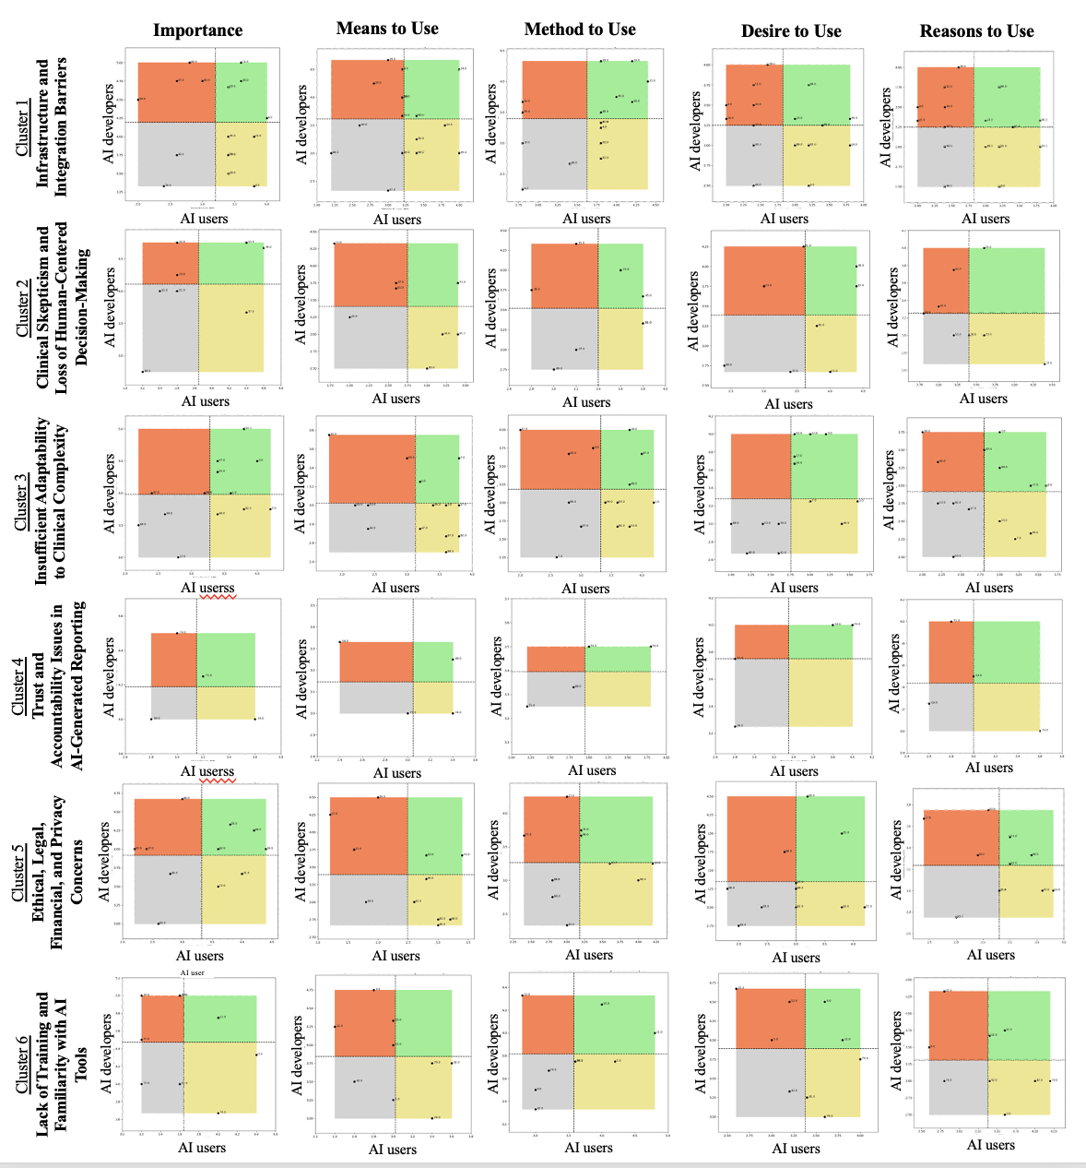

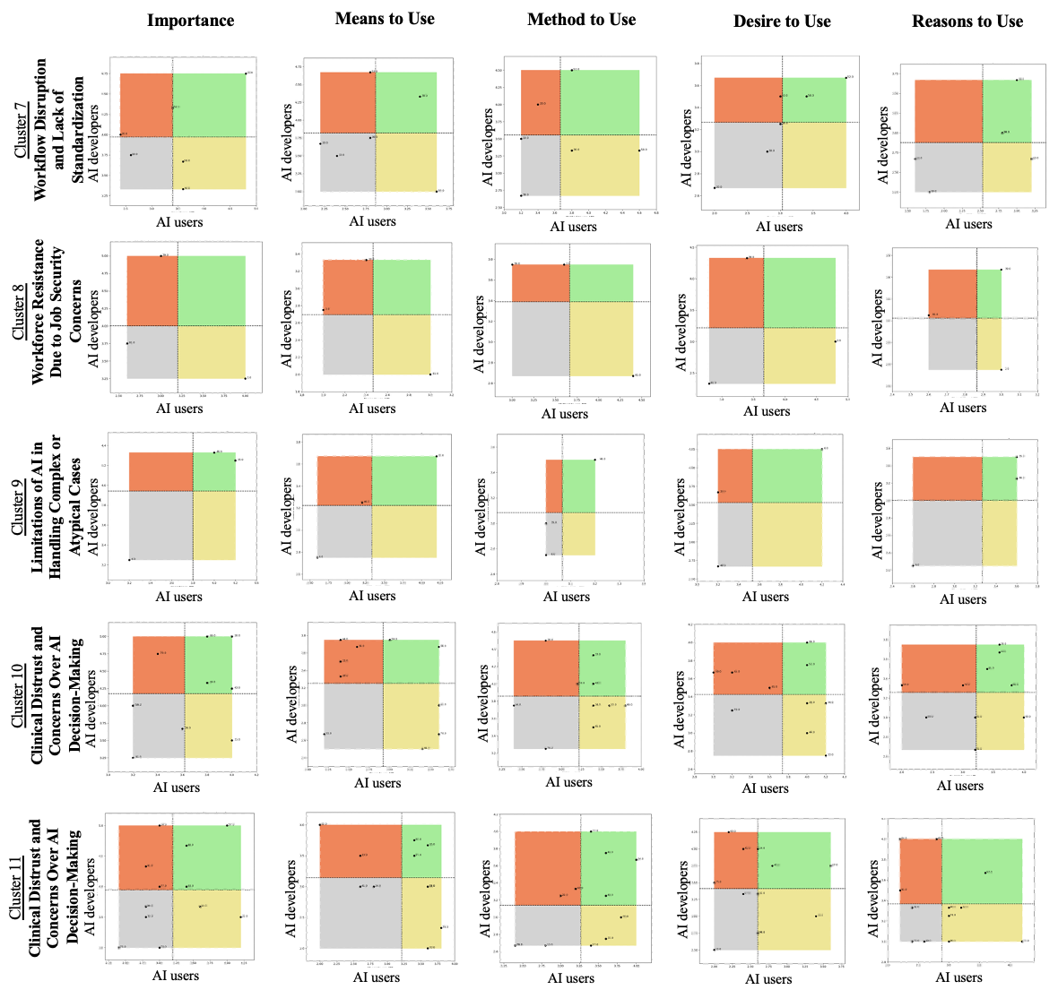

**Supplemental Figure S1.** All Go-zone Plots for 11 Clusters.Go-Zone plots for each major cluster across five evaluation dimensions (Importance, Means to Use, Method to Use, Desire to Use, and Reasons to Use), comparing ratings from AI Users (x-axis) and AI Developers (y-axis). Quadrants indicate the relative priority and feasibility of statements within a cluster: upper-right (green) = above-average ratings from both groups (“Go-Zone”); upper-left (orange) = high AI Developer ratings but low AI User ratings; lower-right (yellow) = high AI User ratings but low AI Developer ratings; lower-left (gray) = below-average ratings from both groups.